# SQL Assignment – Identifying primary and foreign keys task

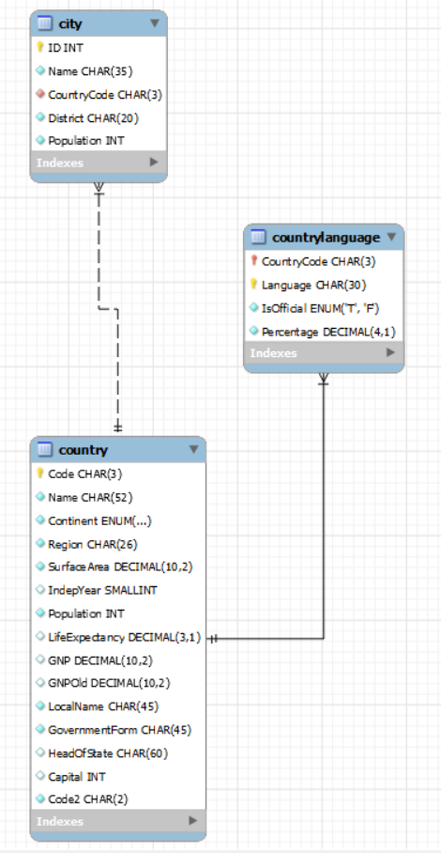

* The primary key in the country table is Code.
* The primary key in the city table is ID.
* The primary key in the countrylanguage table is a composite key consisting of CountryCode and Language.
* The foreign key in the city table is CountryCode.
* The foreign key in the countrylanguage table is CountryCode.